**Quiz Game Application**

**IDE: CodeBlocks**

Setting up arguments and level (1-6) of difficulty on the game. Example:Quiz.txt 2 (1-6)

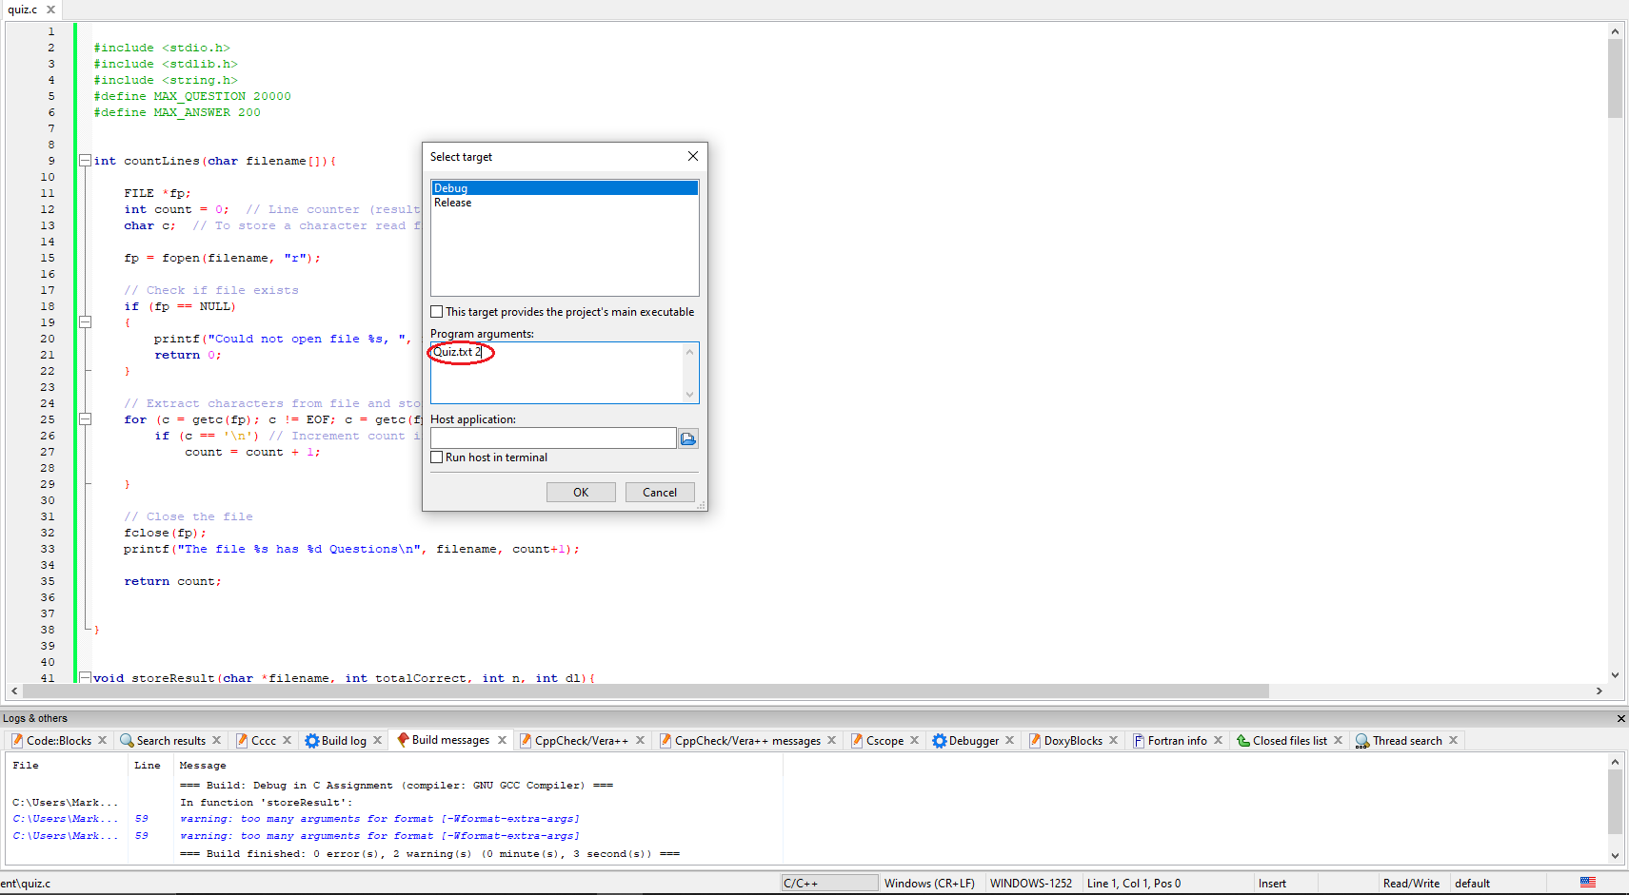

**Screenshots**

